EXERCISE NO:11

REGISTER NO:1518102103

Name:S.PREYATHARSENI

Aim: To write a python obtain greatest common divisor(gcd)of two given numbers.

Program:

def gcd(a,b):

if(a==0):

return a

if(b==0):

return b

if(a==b):

return b

if(a>b):

return(gcd(a-b,b))

else:

return gcd(a,b-a)

a=int(input("enter first number:"))

b=int(input("enter second number:"))

GCD=gcd(a,b)

print("GCD is:")

print(GCD)

link: <http://103.53.53.18/mod/vpl/forms/edit.php?id=326&userid=1707#>

output:

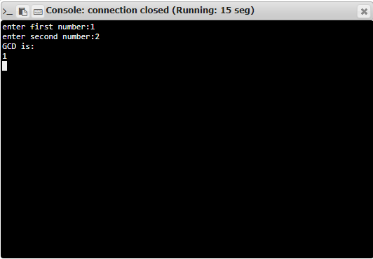

Result: Thus, the code has been successfully executed and output is verified. ­­­­­